Instructions for filling out
Shop Intake Form
Download Excel: YOURNAME-SAA-shop-inventory-spreadsheet.xlsx
DO NOT EMAIL US PICTURES, SCANS, OR PDF OF YOUR SPREADSHEET. WE CAN NOT USE THEM.
Using Excel (Microsoft Office) on PC, Windows, or Mac
- Download the spreadsheet file to tour PC.
- Open with Inventory Spreadsheet file using Microsoft Excel software on your PC
- Edit as per instructions below
- "SaveAs" with file name to include your first and last name
- Print the file to bring with you
- Email the file to Shop@salemArts.org
Using "Numbers" software on a Mac or iPad
- Download the spreadsheet file to your Mac.
- Open the Inventory Spreadsheet file using "Numbers" software on your Mac
- Edit as per instructions below
- "SaveAs" with file name to include your first and last name
- Then "Export To" (under the FILE menu) to Excel format.
- Save theExcel format on your Mac
- Print the file to bring with you
- Email the file to Shop@salemArts.org
Using "Google Sheets" on any web browser (Chrome, Safari, Edge, Etc)
- If you do not have a spreadsheet app on your device, you can use "Google Sheets". Just save the spreadsheet to your device, go to "google sheets".
- Click the "Go To Sheets" button on the info page
- Start a new blank sheet. click "File->open>", then "upload" and select the saved file.
- Choose "Open With" goole sheets the top the Inventory Spreadsheet screen
- Edit as per instructions below
- Select FILE > Download > Microsoft Excel (.xlsx)"
- Rename the file to include your first and last name
- Print the file to bring with you (FILE > Print)
- Email the file to Shop@salemArts.org
Using Mobile Phones or Tablets
- Microsoft Office offers Excel apps for iPhone, iPad, and Android.
- Follow "Excel" instructions above
- Print the file to bring with you
- Email the file to Shop@salemArts.org
If All Else Fails
- If you really cannot produce a spreadsheet, you can click here to print this form, then fill it out and someone at SAA will help you create the spreadsheet on one of our computers.

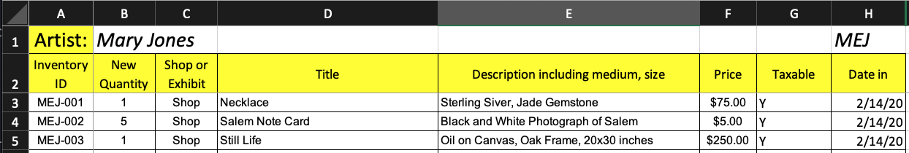

- Artist: Type your full name in the box next to Artist (replace instruction text).
- Initials: Type your initials in the box - e.g. Mary Elizabeth Jones = MEJ. This is also the first part of your inventory ID, (replace instruction text).
- Inventory ID: This is your 3 initials, then a dash, then item number.

  - Item numbers use consecutive three-digit numbers. Your inventory will begin with 001, 002, 003, etc. Each time you drop off new items continue numbering where you left off on your previous inventory form. Do not add to old forms. always start with a new inventory form .
  - Each UNIQUE item MUST have a unique inventory ID.
  - For example, Jane Elizabeth Jones with three pieces in February would be: MEJ-001, MEJ-002 and MEJ-003. BE CAREFUL TO BE CONSISTENT WITH YOUR INITIALS.
- New Quantity: Enter the quantity of the item you are submitting

  - Items with same title, description, and price may be entered with ONE inventory ID and appropriate quantity (e.g. same note cards)
- Shop or Exhibit: select “Shop”
- Title: Provide a title for each item (no quotation marks). This information will be displayed on tags and online shop with your name.
- Description: Enter a description of the item. Include a detailed description of medium, materials, framing, and size (inches).
- Price: Enter the price in dollars and cents.
- Taxable: Enter Taxable, Yes or No. Clothing is non-taxable. Most other things are taxable.
- Date In: Enter the Drop off Date
- File Name: Change the file name to include your first and last name

Drop Off at Salem Arts
Deliver inventory to shop, along with a printed copy of the completed Shop Take-in Form on designated drop off day or by appointment.
If you can not print please let us know when you send your files and we can print at the gallery during take in times.
- Make sure your name, artwork title, Inventory ID, and price are attached to all of your items.
Email shop@SalemArts.org with questions or to request an appointment.

